Unit 7-1 Recitation Activity

Note: There are several Geogebra problems along the way. Perhaps use these as a whole class directly from the open-resource?

Note: The bulk of these activities are from the Active Reading Resource (which will be denoted by “AR”).  5.1 and 5.2 are shifts only, while 6.1-6.3 includes vertical stretches and not many problems with horizontal stretches.

**7-1-1 Shifts**

1. If x = -b/2a is the x-coordinate of the vertex of the parabola , what is the x-coordinate of the vertex of the parabola ?
2. AR 5.1.1:  Given the function , write a formula for each expression below.
3. f(x+6)=   b. f(x)+6=  c. 3f(x)=  d. 5f(x-4) = e. -5f(x-4) =

OR

  APC 1.8 HW #5: The graph of f (x) contains the point (9, 4). What point must be on each of the following transformed graphs?

(a) f (x − 6) (b) f (x) − 5 (c) f (x + 2) + 7

OR

AR 5.1.15 Geogebra:  The graph starts by showing the parabola f(x)= Moving the slider will change the function by adding a number k to the output (#16: f(x+h)+k (negatives allowed)).

Use the slider to change the value of k to the number 5. What happened to the graph as you changed the formula to ?

Notice that the graph shows the coordinates of the lowest point (the *vertex*). Which equation below would graph as a parabola with a vertex at the point (0,−3)?

(i) y=f(x)−3=   
 (ii) y=f(x)+3=  
 (iii) None of these

OR

AR 5.1.16 (Geogebra)

1. The graph starts by showing the function y=f(x)=. Moving the sliders will change the function by adding a number k to the output, and a number h to the input.

What happens to the graph as you change the formula to ?

1. Which equation below would graph as a parabola with a vertex at the point (5,3)?

(i) f(x+5)+3=+3 (ii) y=f(x−5)+3+3 (iii) y=f(x−3)+5=+5

(iv) y=f(x+3)−5=(−5 (v) None of these.

OR

AR 5.2.7:  The function  is graphed below.

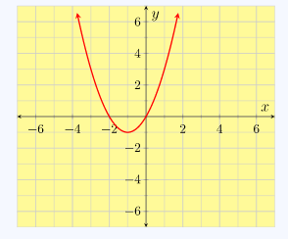

If you wanted to move this graph so it had the same shape, but it was 3 units to the right and 2 units down, what would be its formula?

OR

AR 5.2.13:  The dashed green graph below shows . The solid red graph shows g(x), which is some transformation of f(x).

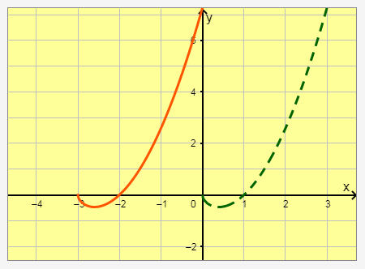

Decide how  was transformed to make g(x). Then, choose the correct formula for g(x) below.

a.    
b.    
c.    
d.    
e. None of these

OR

OR

AR 5.2 HW #3:  Consider the graph of f(x) given below:

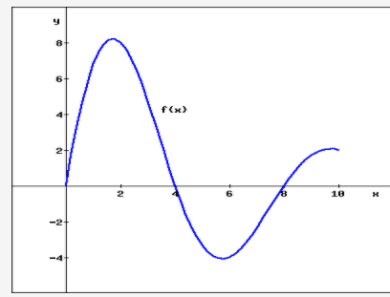

Find a possible formula for the transformations of f(x) shown below:

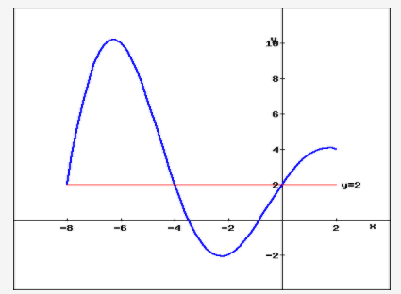

OR

AR 5.2 HW #15

Describe a series of shifts which translates the graph  back onto the graph of

OR

AR 5.2 HW#16; 

1. (-6, 8)
2. (-9, 14)

OR

5.2 HW#20: In each of the following, describe the shift(s) required to transform the second function into the first:

  (a) The graph of  from the graph of

|  |  |  |
| --- | --- | --- |
|  |  |  |
|  |  |  |

(b) The graph of  from the graph of

(c) The graph of  from the graph of

|  |  |  |
| --- | --- | --- |
|  |  |  |
|  |  |  |

(d) The graph of  from the graph of

|  |  |  |
| --- | --- | --- |
|  |  |  |
| OR |  |  |

AR 5.2 HW #21:  The graph of f(x) contains the point (−7,8). What point must be on each of the following transformed graphs? Enter points as (a,b) including the parentheses.

(a) The graph of f(x−5) must contain the point

(b) The graph of f(x)−8 must contain the point

(c) The graph of f(x+6)+5 must contain the point

OR

AR 5.2 HW #23:  The table below contains the values of the function y = f(x).



Each function in parts (a) – (c) is a translation of f(x). In each case, the function can be written in the form y = f(x+h) + k, where h and k represent the corresponding horizontal and vertical shifts. For each of the tables below find a possible formula by applying transformations to f(x).

*EXAMPLE:* if the values for a function k(x) are:

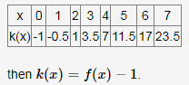

(a)



(b)



(c)

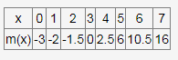

1. MFG 2.3 HW:  For Problems 7–18,

Describe how to transform one of the basic graphs to obtain the graph of the given function.

Using guidepoints, sketch the basic graph and the graph of the given function on the same axes. Label the coordinates of three points on the graph of the given function.

1. b. c. d.

OR

AR 5.2.9:  The function  is graphed below.

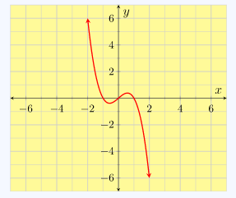

A different function, , is a certain transformation of g(x).

Describe what transformations were done to g(x) to make h(x).

Then sketch a graph of  by hand.

OR

1. AR (Series of problems selected from 5.1.5 – 5.1.14): The Swimmer: In preparation for the swimming competition, a swimmer jumped off a diving board into a swimming pool below. Below is a graph of her height above the water as a function of time.

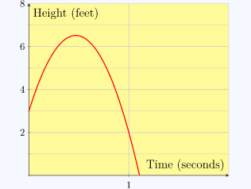

You can see some basic information from the graph:

1. How high was the diving board?
2. When did the swimmer reach the water?
3. What was her maximum height above the water?

AR 5.1.7: (Geogebra) The graph here shows the swimmer’s height above the water when she jumped off the regular diving board.

After this dive, she decided to jump off the high-dive board, which is 7 feet higher than the regular diving board. Click and drag (or sketch the new graph) the vertical intercept to move the graph to match this new situation.

1. What was the swimmer’s beginning height above the water?
2. What changed about the swimmer’s maximum height?
3. What changed about the time she reached the water?

AR 5.1.12:  (Geogebra) The graph below shows

which is the swimmer’s height above the water when she jumped off the regular diving board at time t=0 seconds.

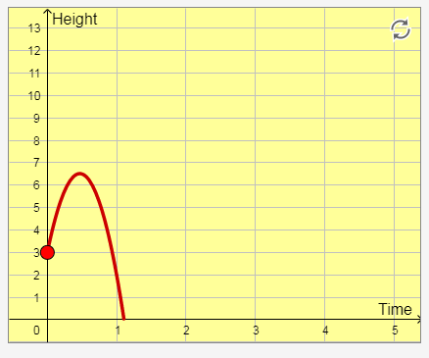

At the competition, the swimmer missed the starting whistle and jumped 2 seconds late. Click and drag the starting point to move the graph to match this new situation.

Jumping late is a change in the input or output?

Which equation below makes sense for this change, h=f(t+2) or h=f(t−2)?

If you simplify each of these formulas, the results are:

And

Graph these two functions on your calculator. Which one matches the graph you made above?

(Followed by commentary on the “surprising” results: “It may have surprised you to see that shifting the graph to the *right* corresponded to *subtracting* a number from the input. To make sense of this, consider one of the other swimmers in the competition who jumped when the whistle sounded. Their height function would be given by h=f(t).

[🔗](https://www.mhcc.edu/precalc1/activity-vertical-and-horizontal-translations.html#p-7146)

If we wanted to find our swimmer's height at, say, 3 seconds after the whistle sounded, it would be the same height as this other swimmer had at only 1 second after the whistle — everything for our swimmer happened 2 seconds late. In other words, to find our swimmer's height after t seconds, this is the same as the other swimmer had 2 seconds before. So for our swimmer, her height is given by: h=f(t−2)” ).

AR 5.1.13:  Recall that the swimmer’s height above the water, after jumping off the regular diving board, was given by:

Suppose the swimmer jumped off the high-dive board, which is 7 feet higher than the regular board, but she did so 3 seconds after the timer started. Alter the formula for f(t) in order to write the formula for her height above the water in this situation.

AR 5.1.14:  Recall that the swimmer’s height above the water, after jumping off the regular diving board, was given by:

Suppose on a particular dive, her height above the water was given by the formula:

1. Did she jump late or early and by how much?
2. Did she jump off the *high-dive* board (7 feet higher than normal), the *Mega high-dive* board (25 feet higher than normal), or the *Nano* board (2 feet lower than normal)?

OR

 AR 5.2.15 (Geogebra):  At 9:00 a.m., a cup of tea was heated to 200 degrees Fahrenheit and then left to sit in a 70 degree kitchen.

The graph of T=f(t) shows the temperature (in degrees Fahrenheit) of the cup of tea as it cooled down toward room temperature, where t is the number of minutes after 9:00 a.m.

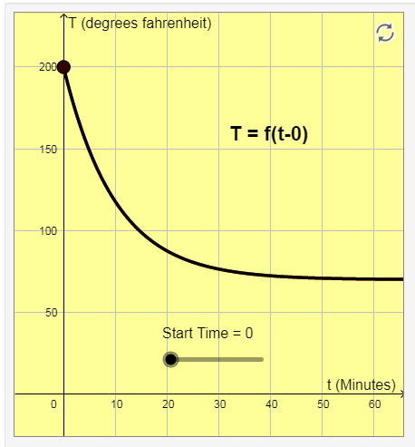

By moving the slider, you can change the time at which the tea stopped heating and began to cool.

Assume the cup of tea began to cool at 9:20 a.m., what would the graph look like and what would the formula look like in terms of f?

OR

OR

AR 5.2.16:  Suppose this is the first week of the year, and T(d) describes the average daily temperature (in degrees) for this week, where d is the day of the year (d=1 for January 1st, etc.).

For each statement below, choose the correct translation which represents the temperature function for that week.

1. “Next week’s temperatures are expected to be an exact repeat of this week.”

The formula for temperature, one week from now, would be:

(i) T(d + 7) (ii). T(d) + 7 (iii). T(d - 7) (iv) T(d) - 7

1. “Two weeks from now, temperatures are expected to be just like this week, but about 5 degrees warmer.”

The formula for temperature, two weeks from now would be:

(i) T(d + 14) + 5   (ii) T(d - 14) + 5 (iii) T(d + 14) – 5 (iv) T(d - 14) - 5

OR

AR 5.2 HW #1:  (Geogebra) The function will approximate the height of an object which was thrown straight upward at a speed of 10 meters per second at time t=0 seconds from a height of 40 meters. See the graph below.

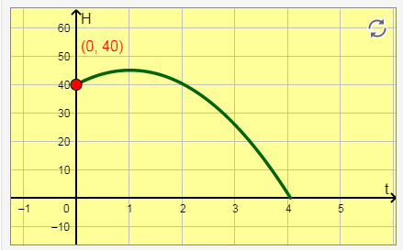

You can move the point to see how high the object will be at a certain time, or when the object will hit the ground.

Now, we can use this function to describe other situations involving such an object. For example, suppose the person had waited until t=1 second before throwing the object.

1. Which graph below shows the height of the object if the person waited 1 second before throwing it?

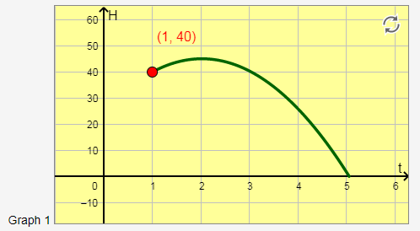 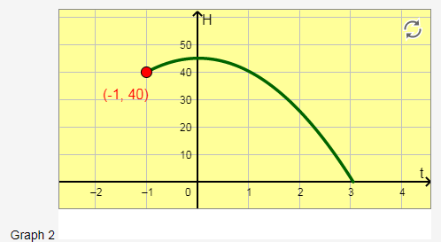

1. Since this is a *horizontal* translation of the original graph h(t), are we changing the *input* or the *output*?
2. In order to correctly shift the graph of h(t), what will we use for the *input* in the formula for the function h?

OR

AR 5.2 HW #2: The function  represents the height of an object which was thrown straight upward at a speed of 10 meters per second, from an initial height of 40 meters.

Suppose now that the person waited 3 seconds and also carried it an additional 12 meters higher in elevation before throwing it.

1. Waiting 3 seconds is a change to the input t, so the input of the function will now be:
2. Carrying the object an additional 12 meters upward before throwing it is a change to the output, so we will add, subtract, or multiply the number 12 to the outside of the function.
3. Putting these transformations together, the formula will now be:

.

OR

5.2 HW #24:  At a jazz club, the cost of an evening is based on a cover charge of $15 plus a beverage charge of $8 per drink.

(a) Find a formula for t(x), the total cost for an evening in which x drinks are consumed.   
t(x)=

(b) If the price of the cover charge is raised by $5, express the new total cost function, n(x), as a transformation of t(x).   
n(x)=  

***Note****: Do not give an explicit formula. Using function notation, write an expression for n(x) by performing the necessary transformations to t(x). For example your answer should be of the form, n(x)=t(x−100)+180 and not of the form n(x)=80x+9.*

(c) The management increases the cover charge to $40, leaves the price of a drink at $8, but includes the first three drinks for free. For x≥3, express p(x), the new total cost, as a transformation of t(x).   
p(x)=

OR

5.2 HW #25:  The table below gives values of T=f(d), the average temperature (in degrees Celsius) at a depth *d* meters in a borehole in Belleterre, Quebec.

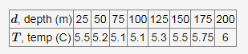

|  |  |  |  |  |  |  |  |  |
| --- | --- | --- | --- | --- | --- | --- | --- | --- |
|  |  |  |  |  |  |  |  |  |
|  |  |  |  |  |  |  |  |  |

Consider the function g(d)=f(d+50) which describes another borehole near Belleterre.   
   
(a) Fill in all of the blanks in the table of values for g(d) for which you have sufficient information. If are unable to determine a value in the table, enter **NONE.** Do not leave any blanks in the table.

|  |  |  |  |  |  |  |  |  |  |  |  |  |  |  |  |  |  |  |  |  |  |  |  |  |  |  |
| --- | --- | --- | --- | --- | --- | --- | --- | --- | --- | --- | --- | --- | --- | --- | --- | --- | --- | --- | --- | --- | --- | --- | --- | --- | --- | --- |
| |  |  |  |  |  |  |  |  |  | | --- | --- | --- | --- | --- | --- | --- | --- | --- | | d, depth (m) | 25 | 50 | 75 | 100 | 125 | 150 | 175 | 200 | | T, temp (C) |  |  |  |  |  |  |  |  | |  |  |  |  |  |  |  |  |
|  |  |  |  |  |  |  |  |  |

   
(b) Which of the statements below best describes in words what the function g(d) tells you about the borehole?   
   
 i. Temperatures in this borehole are 50 degrees Celsius cooler than at the same depth in the Belleterre borehole.   
   
 ii. Temperatures in this borehole are 50 degrees Celsius warmer than at the same depth in the Belleterre borehole.   
   
 iii. If the temperatures in both boreholes are the same, then you will be 50 meters deeper in this borehole than if you were in the borehole in Belleterre.   
   
 iv. If the temperatures in both boreholes are the same, then you will be 50 meters closer to the top of this borehole than if you were in the borehole in Belleterre.   
   
 v. None of the above

5. AR 5.2.19:  The graph of a function y=g(x) is shown below.

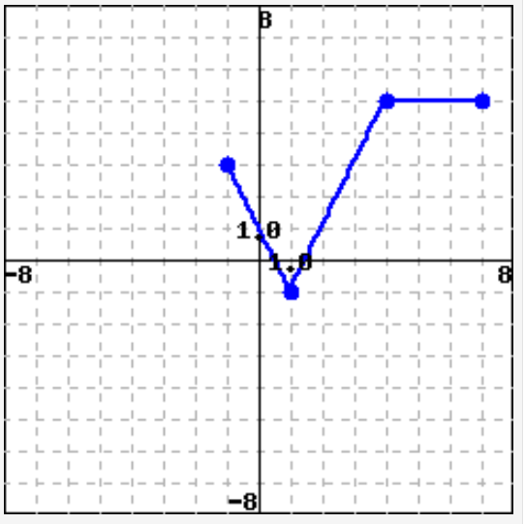

1. What would be the *domain* of y=f(x+3)?
2. What would be the *range* of y=f(x−1)−2?

**(Problems including vertical or horizontal stretches, including reflections):**

1. AR 6.1.1;

a. If f(3) means “the output when the input is 3”, what does 6⋅f(3) mean?

i. 18   
 ii. 6 times the input of 3   
 iii. 6 times the output when x is 3

b. If f(3)=7, then what is 6⋅f(3)?

OR

AR 5.1.4:  Beginning with the function y=g(t), write an equation which matches each description.

1. “We subtracted 5 from the input and added 4 to the output.”  y =
2. “We doubled the input and then subtracted 1 from the output.”  y=
3. “We multiplied the output by 7.”  y =

OR

AR 6.1.6:  Suppose h(−4)=5.

a. What point is on the graph of y = h(x)?

   (i). (-4,5)

(ii) (-4,-5)

(iii) (4,5)

(iv) (4,-5)

b. What point is on the graph of y = −h(x)?

   (i). (-4,5)

(ii) (-4,-5)

(iii) (4,5)

(iv) (4,-5)

OR

AR 6.1.9:  Suppose h(5)=9 and h(−5)=13 for some function h.

1. What point must be on the graph of y = h(x)?

(i) (5, 9)

(ii) (5, 13)

1. What point must be on the graph of y=h(−x)?

(i) (5, 9)

(ii) (5, 13)

OR

OR

AR 6.2.8:  The function  contains the points (0,0) and (2,8).

Suppose we want to vertically stretch our function so that it still contains the point (0,0), but now contains the point (2,12).

This means we have multiplied the outputs of our original function by some number k.

1. What is the value of k?
2. What is the formula for this new function?

OR

AR 6.1.12:  Complete the table below, using  . If an expression cannot be evaluated, write *DNE* (“does not exist”) in that space.

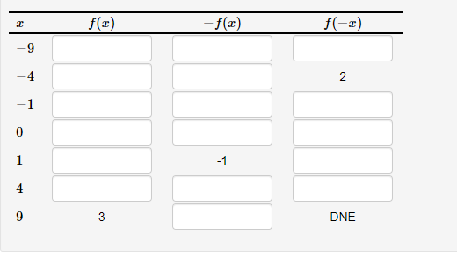

OR

AR 6.3 HW#6:

1. Complete the table below so that the function f(x) is EVEN. (f(x) should be defined for all values of the domain shown.)

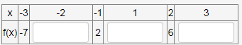

|  |  |  |  |  |  |  |
| --- | --- | --- | --- | --- | --- | --- |
|  |  |  |  |  |  |  |
|  |  |  |  |  |  |  |

(b) Complete the table below so that the function g(x) is ODD. (g(x) should be defined for all values of the domain shown.)

|  |  |  |  |  |  |  |  |  |
| --- | --- | --- | --- | --- | --- | --- | --- | --- |
|  |  |  |  |  |  |  |  |  |
|  |  |  |  |  |  |  |  |  |
|  |  |  |  |  |  |  |  |  |

*(NOTE: There is now an extra value you need to determine when x=0)*

OR

OR

AR 6.3 HW#23:  The point (−7,4) is on the graph of y=g(x). Give the coordinates of one point which must be on the graph of each of the following functions.

(a) 12g(x)

(b) g(12x)

(c) −2 g(x).

(d) --g(2x)

OR

AR 6.3 HW#38:  Suppose that f(x) has a domain of [3,18] and a range of [2,18]. determine the domain and range of:

(a) **f(x)+5** (b) f(x+5)    (c) f(5x)   (d) 5f(x)

OR

AR 6.3 HW#24 (also #35):   Fill in all of the blanks in the table below for which you have sufficient information. If you do not have enough information to fill in a blank, type **NONE**in the blank space provided. Do not leave any blanks empty.

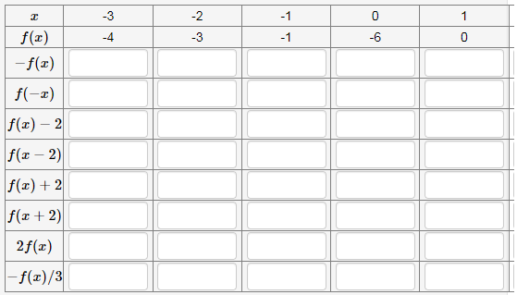

OR

OR

AR 5.2 HW #14

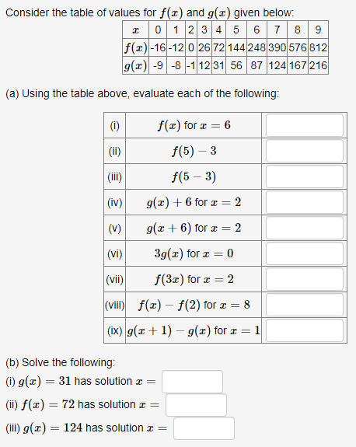

OR

MFG 2.3 HW#39-42;  In Problems 39–42, each table in parts (a)–(d) describes a transformation of f(x)*.* Identify the transformation and write a formula for the new function in terms of f.

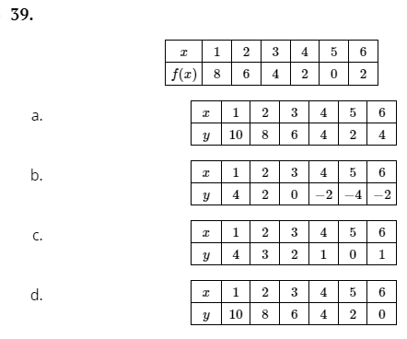

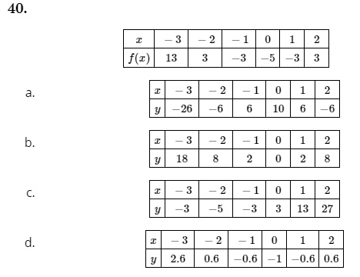

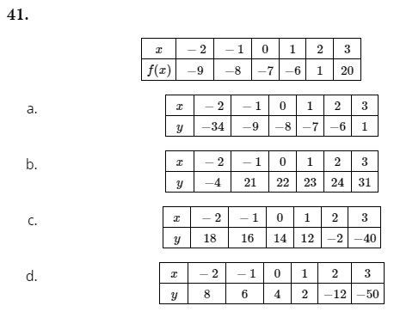

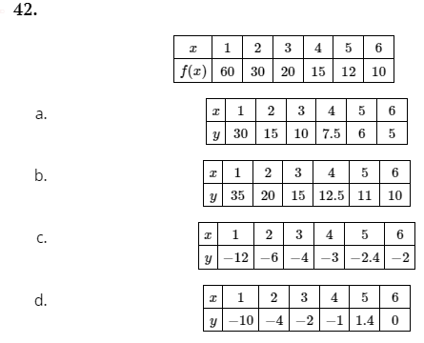

OR

S-Z 1.7 p. 140 (HW #1-18):  Suppose (2, −3) is on the graph of y = f(x). In each of the following, find a point on the graph of the given transformed function.

1. b. c. d. e. f. g.

h. . i. . j. . k. . l.

m.

OR

APC 1.8 HW: p. 97:  The figure below is the graph of the function m(t). Let n(t) = m(t) + 2, k(t) = m(t + 1.5),w(t) = m(t − 0.5) − 2.5 and p(t) = m(t − 1). Find the values of the following:

a. n(−3) b. n(1) c. k(2) d. w(1.5) e. w(−1.5)

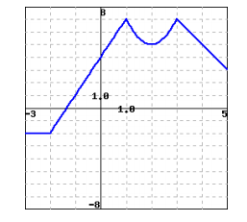

OR

AR 6.3 HW#25:   If the graph of the line y=mx+b is reflected over the x-axis, what will be the slope and intercepts of the new graph? (Your answers will depend on the parameters b and m.

(a) The slope will be

(b) The y-intercept will be y=

(c) The x-intercept will be x=

OR

AR 6.3 HW#28:  Starting with the graph of y = ln x, find the equation of the graph that results from:

(a) shifting 2 units upward: y =   
(b) shifting 2 units to the left. y =  
(c) reflecting about the x-axis. y =  
(d) reflecting about the y-axis. y =  
(e) reflecting about the line y=x.  y =  
(f) reflecting about the x-axis and then the line y=x.  y =  
(g) reflecting about the y-axis and then the line y=x.  y =  
(h) shifting 2 units to the left and then reflecting about the line y=x.  y =

OR

AR 6.3 HW#30:  Which of the following explains how to obtain the graph of from the graph of ?   
   
(a) Reflect the graph of about the y-axis and then shift this result up 3 unit.   
(b) Reflect the graph of about the y-axis and then shift this result to the right 3 units.   
(c) Reflect the graph of about the x-axis and then shift this result up 3 unit.   
(d) Reflect the graph of about the x-axis and then shift this result to the right 3 units.

OR

S-Z 1.7 p. 142 HW #54-63:  Let . Find a formula for a function g whose graph is obtained from f from the given sequence of transformations.

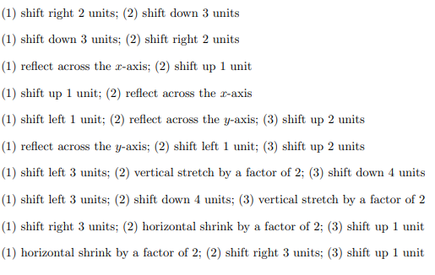

OR

AR 6.3 HW#37:  Describe a function g(x) in terms of f(x) if the graph of g is obtained by reflecting the graph of f about the x-axis and if it is horizontally stretched by a factor of 2 when compared to the graph of f.   
g(x)=Af(Bx)+C where A -= ?, B = ? and C = ?

OR

FM 4.1:  Given parent function of ,

a. Write the function that has a vertical shift down of 5 and horizontal shrink by a factor of 1/3.

b. Write the function that has a horizontal shift right of 2, vertical shift up 3, and vertical stretch by factor of 4.

c. Write the function that has a vertical stretch of 6, vertical shift down 3, horizontal shift right 5, and reflected about the x-axis.

d. Write the function that has a vertical stretch of 5, reflect about the y-axis, and horizontal stretch of 3.

OR

Calc-Medic  1.6:  (Exploration of orders):  I took the graph of and performed the following four transformations:

(i) Vertical shift up 3 (ii) Horizontal shift to the left 1 (iii) Reflection over x-axis

(iv) Vertical stretch by a factor of 2

Unfortunately, I can’t remember the order in which I carried out the four transformations. All I know is that I ended up with the graph of

Can you find an order in which I could have carried out the transformations? Is there more than one way of doing this? If so, can you find them all?

Can you explain why different orders can lead to the same outcome?

What other parabolas could I have ended up with if I had performed the four transformations in a different order?

OR

FM 4.1 In each of the following, describe the transformation that happens to the function f(x):

1. b. c.

OR

MFG 2.3 2.40:  The graph of y=g(x) has a vertical asymptote at x=−4. What happens to the asymptote under a vertical translation?

(i) Nothing. (ii) It is compressed vertically. (iii) It is translated vertically.

(iv) It is eliminated.

OR

MFG 2.3 2.53:  The graph of y = F(x) is symmetric about the y-axis. Which of the following graphs is also symmetric about the y-axis??

(a) y = −3F(x)   
(b) y = F(x)−3   
(c) y = F(x−3)   
(d) Both (a) and (b)

OR

FM 4.1 In each of the following, name the parent function. Then describe the transformation of the function.

1. b. c.
2. AR 6.1.10 Geogebra:  The function y=g(x) is shown below.

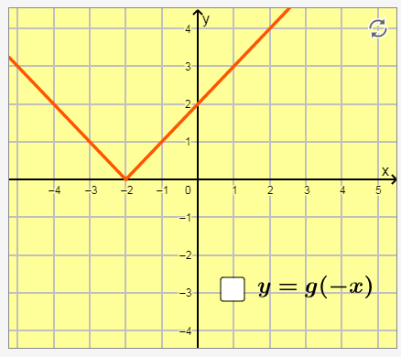

Click to graph the transformation y=g(−x). Use it to complete each statement below.

1. To evaluate g(−x) when x=2, we are really evaluating:

(i) g(2)

(ii) g(-2)

1. What is the value of g(−x) when x=2?
2. To evaluate g(−x) when x=−1, we are really evaluating:

(i) g(1)

(ii) g(-1)

1. What is the value of g(−x) when x=−1?
2. The graphs of y=g(−x) and y=g(x) are reflections of each other over the

(i) x-axis

(ii) y-axis

OR

MFG 2.3 HW#23-32:  For each of the following,

Identify the scale factor for each function and describe how it affects the graph of the corresponding basic function.

Using guidepoints, sketch the basic graph and the graph of the given function on the same axes. Label the coordinates of three points on the graph of the given function.

1. b. c.

OR

Exploration: APC 1.8 p. 85; Preview Activity 1.8.1. Open a new Desmos graph and define the function . Adjust the window so that the range is for −4 ≤ x ≤ 4 and −10 ≤ y ≤ 10.

a. In Desmos, define the function g(x) = f (x)+a. (That is, in Desmos on line 2, enter g(x) = f(x) + a.) You will get prompted to add a slider for a. Do so. Explore by moving the slider for a and write at least one sentence to describe the effect that changing the value of a has on the graph of 1.

b. Next, define the function h(x) = f (x − b). (That is, in Desmos on line 4, enter h(x) = f(x-b) and add the slider for b.) Move the slider for b and write at least one sentence to describe the effect that changing the value of b has on the graph of h.

c. Now define the function p(x)= c f (x). (That is, in Desmos on line 6, enter p(x) = cf(x) and add the slider for c.) Move the slider for c and write at least one sentence to describe the effect that changing the value of c has on the graph of p. In particular, when c= −1, how is the graph of p related to the graph of f ?

d. Finally, click on the icons next to g, h, and p to temporarily hide them, and go back to Line 1 and change your formula for f . You can make it whatever you’d like, but try something like or . Then, investigate with the sliders a, b, and c to see the effects on g, h, and p (unhiding them appropriately). Write a couple of sentences to describe your observations of your explorations.

OR

AR 6.1.15 (NOTE: 6.1.16 does g(-x))  :  To graph the transformation y = −f(x), it is helpful to begin with the graph of y = f(x) and select a few points on it. Then, reflect those points over the x-axis, and complete the sketch of the reflected function y = −f(x).  Move the slider on the graph above, and the graph will be reflected over the x-axis to make y = −f(x).

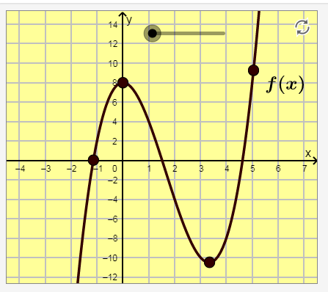

Notice that the point (−1,0) didn’t move as you changed the slider. Why not?

OR

AR 6.2.4:  The graph shows a function y=f(x).

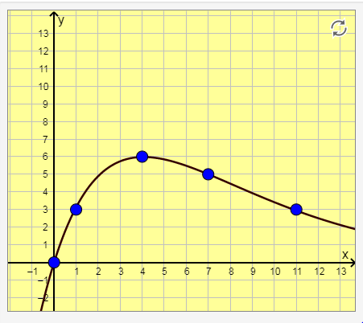

The first column of the table below shows output values for the function f.

Use those values to determine the values in the next two columns for 2⋅f(x) and ⋅f(x). Remember that multiplying *outside* of a function by a number will change its *output* values.

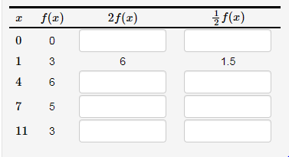

OR

OR

AR 6.2.6 : Geogebra (6.2.7: Negatives allowed):  The graph below shows a function y=f(x).

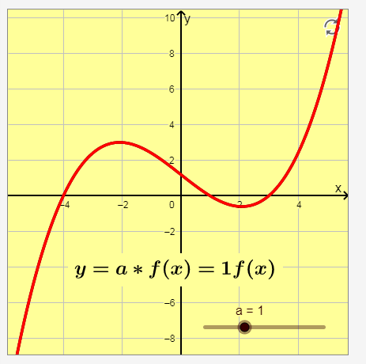

Moving the slider allows you to also graph y=a⋅f(x), where you can change the value of a between 0 and 3.

Move the slider so a>1, and use what you observe to complete the statement below:

1. To graph y=af(x) when a>1, you would begin with y=f(x) and

(i) stretch it away from OR (ii) compress it toward

 the x-axis.

Now, move the slider so that 0<a<1, and use what you observe to complete the statement below:

1. To graph y=af(x) when 0<a<1, you would begin with y=f(x) and

(i) stretch it away from OR (ii) compress it toward

 the x-axis.

OR

OR

AR 6.3 HW#14: Consider the graph of f(x) given below:

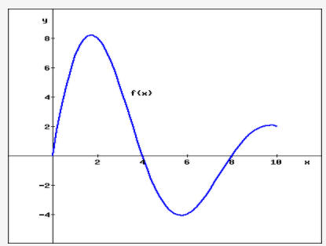

Find a possible formula for the transformations of f(x) shown below:

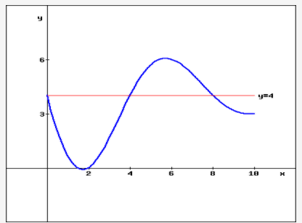

OR

AR 6.3.17:  A function y=f(x) is graphed below, together with a transformation y=g(x).

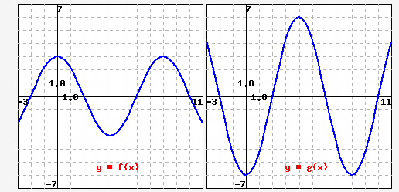

Suppose g(x) = k⋅f(x) for some constant number k. What is k?

OR

AR 6.3.19:

The graph of the function y=f(x) is shown below.

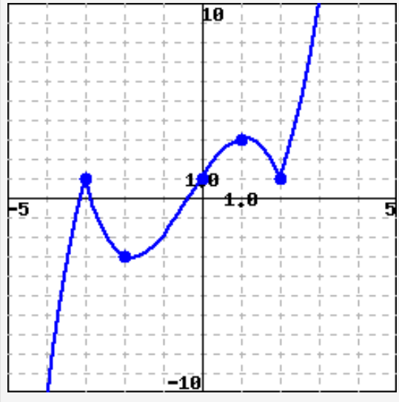

Four transformations of y=f(x) are shown. Use them to answer the questions that follow.

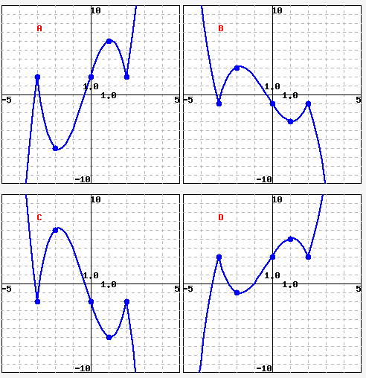

1. Which graph is y = −f(x)?
2. Which graph is y = 2f(x)?
3. Which graph is y = −2f(x)?
4. Which graph is y = f(x) +2?

OR

AR 6.3.20:  In this problem, you will use an arbitrary function f(x). Write an expression using function notation to match each function transformation described below.

1. Shift the graph of y = f(x) to the right by 6 units, and then vertically compress it by a factor of 0.2.  Answer: y=
2. Vertically stretch the graph of y = f(x) by a factor of 6.5, and then vertically shift it downward by 11 units. Answer: y=
3. Vertically shift the graph of y = f(x) downward by 11 units, and then vertically stretch it by a factor of 6.5. Answer: y=
4. Reflect the graph of y = f(x) over the y-axis, and then shift it upward by 12 units. Answer: y=
5. Shift the graph of y = f(x) to the left by 10 units, then compress it vertically by a factor of 0.7, and then reflect it over the x-axis. Answer: y=

OR

OR

AR 6.3 HW# 12 Consider the function y=f(x) drawn below:

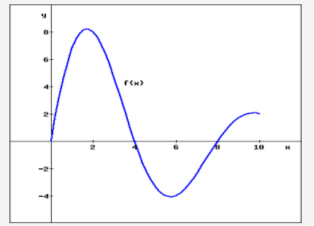

On a separate piece of paper, sketch an accurate graph of the function y = −2f(−x) . Which (if any) of the graphs below matches the graph you drew?

1. B. C.

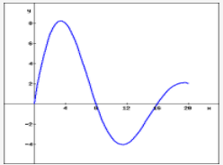  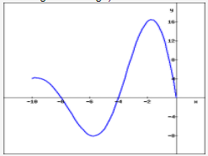 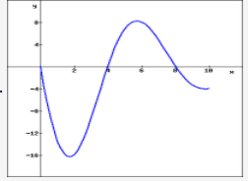

D. E. F.

. 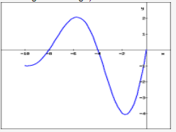 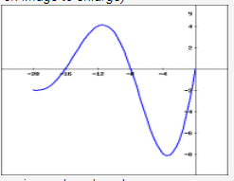 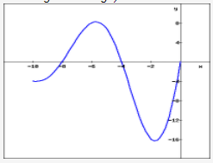

OR

OR

6.3HW#13:  The graph of y=f(x) is given below (in blue), along with several related graphs (which are in red).

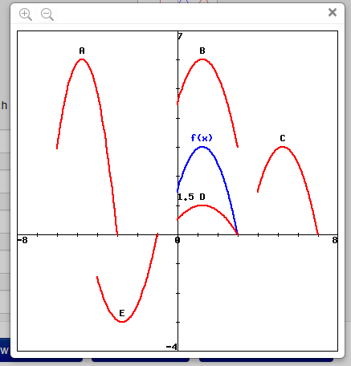 

   
For each equation, enter the letter of the corresponding graph.   
   
   (i) y=−f(x+4)  (ii)  y=f(x)+3  (iii)  y=2f(x+6)  (iv) y=f(x−4)

OR

MFG 2.3 HW#63-64:  Each graph can be obtained by two transformations of the given graph. Describe the transformations and write a formula for the new graph in terms of f.

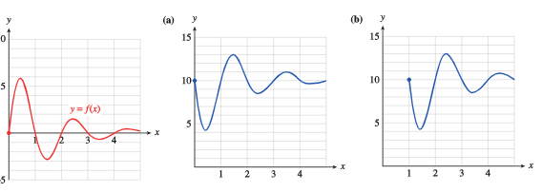

OR

AR 6.3 HW#34: The function  is given graphed below:

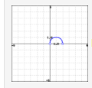

(A) Starting with the formula for f(x), find a formula for g(x), which is graphed below:

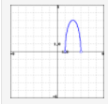 

(B) Starting with the formula for f(x), find a formula for h(x), which is graphed below:

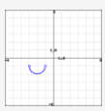

  OR

APC 1.8 p. 98 HW #8:  (exploration of horizontal stretches):  We have explored the effects of adding a constant to the output of a function, y = f (x) + a, adding a constant to the input, y = f (x + a), and multiplying the output of a function by a constant, y = a f (x). There is one remaining natural transformation to explore: multiplying the input to a function by a constant. In this exercise, we consider the effects of the constant a in transforming a parent function f by the rule y = f (ax). Let .

a. Let g(x) = f (4x), h(x) = f (2x), k(x) = f (0.5x), and m(x) = f (0.25x). Use Desmos to plot these functions. Then, sketch and label g, h, k, and m on the provided axes in the figure below along with the graph of f . For each of the functions, label and identify its vertex, its y-intercept, and its x-intercepts.

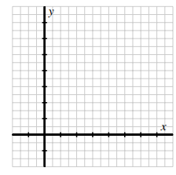

1. Based on your work in (a), how would you describe the effect(s) of the transformation

y= f (ax) where a > 0? What is the impact on the graph of f ? Are any parts of the graph of f unchanged?

1. Now consider the function r(x) = f (−x). Observe that r(−1) = f (1), r(2) = f (−2), and so on. Without using a graphing utility, how do you expect the graph of y = r(x) to compare to the graph of y = f (x)? Explain. Then test your conjecture by using a graphing utility and record the plots of f and r on the axes in the figure below.

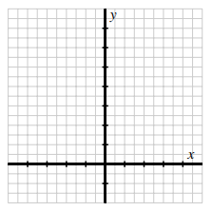

d. How do you expect the graph of s(x) = f (−2x) to appear? Why? More generally, how does the graph of y = f (ax) compare to the graph of y = f (x) in the situation where a < 0?

**OR**

FM 4.1 Match the function to its graph without using graphing technology.

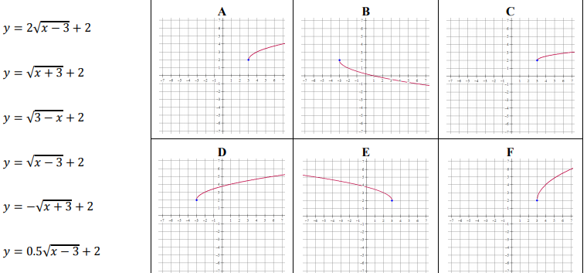

FM 4.1 Given the graph of h(x) shown below:

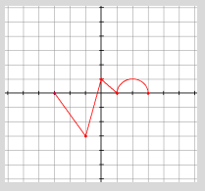

   Sketch a graph of each of the following:

1. – h(x) b. h(-x) c. h(x) + 2 d. h(x + 2) e. h(x - 1) + 2 f. – h(x + 3) – 2

g. 2h(x) h. h(2x) i. h(x) j. k. – 2h(x – 1) + 3

S-Z 1.7 p. 141:  The complete graph of y = f(x) is given below. In each of the following, graph the given transformed function.

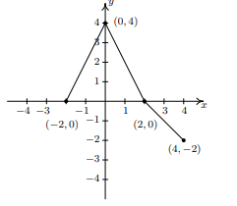

1. y = f(x) + 1 b. y = f(x) − 2 c. y = f(x + 1) d. y = f(x − 2) e. y = 2f(x) f. y = f(2x)

g. y = 2 − f(x) h. y = f(2 − x) i. y = 2 − f(2 − x). j. y = -f(x) k. y = f(-x)

l. y =

S-Z 1.7 p. 143 HW#64:  The graph of is given below on the left and the graph of y = g(x) is given on the right. Find a formula for g based on transformations of the graph of f. Check your answer by confirming that the points shown on the graph of g satisfy the equation y = g(x).

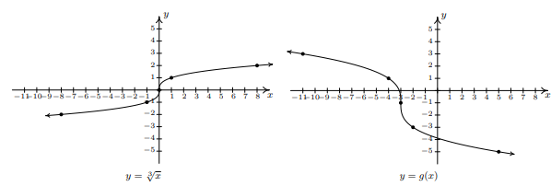

S-Z 1.7 p. 143 HW#67-70:

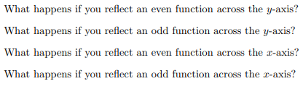

MFG 2.3 HW:  In Problems 1–6, identify the graph as a translation of a basic function, and write a formula for the graph.

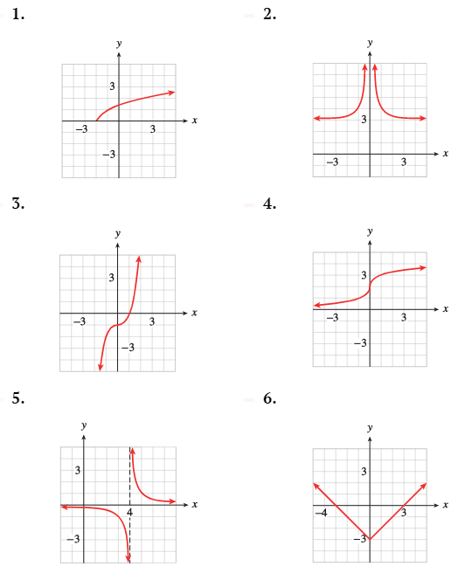

OR

MFG 2.3 HW#35-38  The graph of a function is shown in red. For each of the following graphs, describe the transformation of the graph; then give a formula for each in terms of the original function.

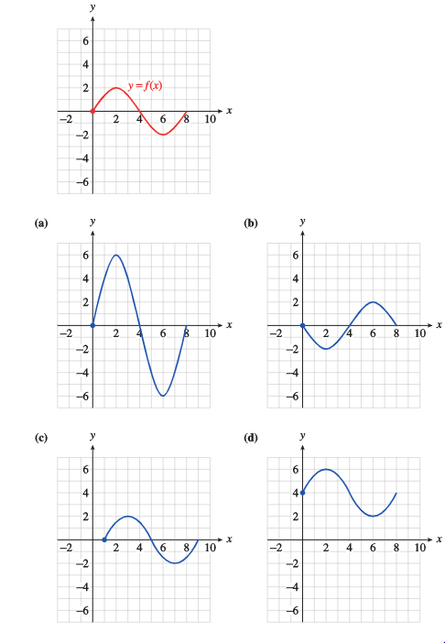

8. AR 6.2.3:  Suppose the function f(x) represents the price of your favorite whole bean coffee, where x represents how many pounds you buy.

Which expression below means “the coffee is only half the regular price”?

(i) 0.5f(x) (ii) f(0.5x)

OR

AR 6.3 HW#1:  Let C=f(n) represent the total cost (in dollars) for a carpenter when she builds n wooden chairs.

(a) If the carpenter currently builds k chairs per week, what do the following expressions represent? Pick one (if any) of the statements which best explains its significance.   
 (i) f(k+10)

* The cost of building 10 more chairs per week.
* An increase in weekly cost by 10 dollars.
* The cost of building 10 chairs less each week.
* A decrease in weekly cost by 10 dollars.
* The number of chairs you can build per week if total cost is increased by 10 dollars.
* The weekly cost if the cost per chair increases by 10 dollars.
* None of the above

 .   
(ii) f(k)+10

* The cost of building 10 more chairs per week.
* An increase in weekly cost by 10 dollars.
* The cost of building 10 chairs less each week.
* A decrease in weekly cost by 10 dollars.
* The number of chairs you can build per week if total cost is increased by 10 dollars.
* The weekly cost if the cost per chair increases by 10 dollars.
* None of the above

 .   
 .   
(iii) f(2k)

* The cost of building 2 more chairs per week.
* Double the weekly cost of building k chairs.  .
* The cost of building twice as many chairs per week.
* The weekly cost if the cost per chair is doubled.  .
* The cost of building half as many chairs per week
* The number of chairs you can build in one week if the weekly cost is doubled.  None of the above
* None of the above

 .   
(iv) 2f(k)

* The cost of building 2 more chairs per week.
* Double the weekly cost of building k chairs.  .
* The cost of building twice as many chairs per week.
* The weekly cost if the cost per chair is doubled.  .
* The cost of building half as many chairs per week
* The number of chairs you can build in one week if the weekly cost is doubled.  None of the above
* None of the above

 .

b) If the carpenter sells her chairs at 70% above cost, plus an additional 4% sales tax on the sale price, write an expression for her gross income (including sales tax) each week.   
Gross Income =

OR

AR 6.3 HW #2:  Let A = f(r) be the area of a circle of radius r.

(a) Write a formula for f(r).

(b) Which expression represents the area of a circle whose radius is increased by 5%?   
  (i). f(r+0.05)  (ii)**.**0.05f(r) **(iii).**f(r)+0.05  (iv)**.**f(5+r) **(v).**f(1.05r)   
 (c) By what percent does the area increase if the radius is increased by 5%?

OR

AR 6.3 HW#39:  Every day I take the same taxi over the same route from home to the train station. The trip is x miles, so the cost for the trip is f(x). Match each story in (a)-(d) to a function in (i)-(iv) representing the amount paid to the driver.

A.   I received a raise yesterday, so today I gave my driver a five dollar tip.   
B.   The meter in the taxi went crazy and showed five times the number of miles I actually traveled.   
C.   I had a new driver today and he got lost. He drove five extra miles and charged me for it.   
D.   I haven't paid my driver all week. Today is Friday and I'll pay what I owe for the week.

(i) f(5x)  (ii) f(x+5)   (iii) f(x)+5 (iv) 5f(x)

OR

**Calc-Medic** 1.5 #4:  (Multiple Choice) Pilar’s parents give him an allowance amount , based on his age, *t*, in years. Which of the following expressions would give the allowance amount of Pilar’s younger sister, who is three years younger than he is?

* 1. b. c. d.

OR

MFG 2.3 2.42:  The function E=f(h) graphed below gives the amount of electrical power, in megawatts, drawn by a community from its local power plant as a function of time during a 24-hour period in 2002. Sketch a graph of y=f(h)+300 and interpret its meaning.

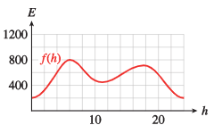

OR

MFG 2.3 2.43:  An evaporative cooler, or swamp cooler, is an energy-efficient type of air conditioner used in dry climates. A typical swamp cooler can reduce the temperature inside a house by 15 degrees.

Figure (a) shows the graph of T=f(t), the temperature inside Kate’s house t hours after she turns on the swamp cooler. Write a formula in terms of f for the function g shown in figure (b), and give a possible explanation of its meaning.

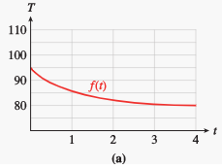 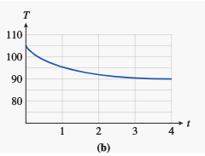

g(t)=

(i) g is the temperature in the house on a day that was 10 degrees hotter.   
 (ii) g is the temperature in the house on a day that was 10 degrees cooler.   
 (iii) g is the temperature in the house 10 hours after turning on the swamp cooler.

OR

MFG 2.3 2.48:  The function N=f(p) graphed below gives the number of people who have a given eye pressure level p from a sample of 100 people with healthy eyes, and the function g gives the number of people with pressure level p in a sample of 100 glaucoma patients.

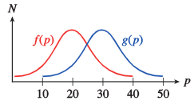

a.Write a formula for g as a transformation of f.

b.  For what pressure readings could a doctor be fairly certain that a patient has glaucoma?

OR

MFG 2.3 2.49:  The function C=f(t) shown below gives the caffeine level in Delbert’s bloodstream at time t hours after he drinks a cup of coffee, and g(t) gives the caffeine level in Francine’s bloodstream. Write a formula for g in terms of f, and explain what it tells you about Delbert and Francine.

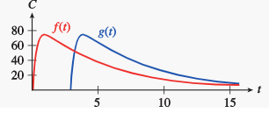

g(t)=

A) Francine drank her coffee 3 hours after Delbert drank his.   
B) Delbert drank his coffee 3 hours after Francine drank hers.   
C) Francine drank 3 time as much coffee as Delbert drank.   
D) Francine drank 3 more cups of coffee than Delbert drank.

OR

MFG 2.3 2.57:  The function A = f(t) graphed below gives a person's blood alcohol level t hours after drinking a martini. Sketch a graph of g(t) = 2f(t) and explain what it tells you.

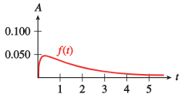

OR

MFG 2.3 2.58:  If the Earth were not tilted on its axis, there would be 12 daylight hours every day all over the planet. But in fact, the length of a day in a particular location depends on the latitude and the time of year.

The graph below shows H = f(t), the length of a day in Helsinki, Finland, t days after January 1, and R = g(t), the length of a day in Rome. Each is expressed as the number of hours greater or less than 12.

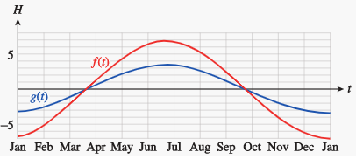

(i) Write a formula for f in terms of g. What does this formula tell you?

(ii) On any given day, the number of daylight hours varies from 12 hours by about...

A) 2 hours more in Helsinki as in Rome.   
B) 3 hours more in Helsinki as in Rome.   
C) twice as much in Helsinki as in Rome.   
D) half as much in Helsinki as in Rome.

OR

MFG 2.3 HW#71:  The graph of f(x) shows the number of students in Professor Hilbert's class who scored x points on a quiz. Write a formula for each transformation of *f* ((a) and (b) of the figure below); then explain how the quiz results in that class compare to the results in Professor Hilbert's class.

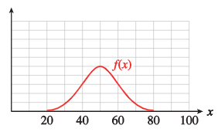

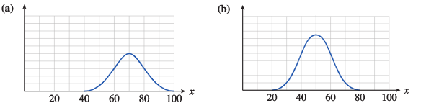

OR

MFG 2.3 HW#72:  The graph of f(x) shows the number of men at Tyler College who are x inches tall. Write a formula for each transformation of f ; then explain how the heights in that population compare to the Tyler College men.

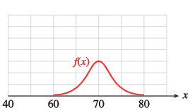

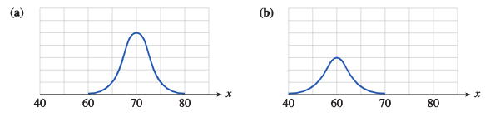

OR

MFG 2.3 HW#75:  The graph of g(t) shows the population of marmots in a national park t months after January 1. Write a formula for each transformation of g and explain how the population of that species compares to the population of marmots.

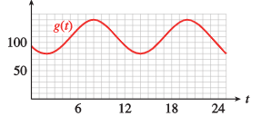

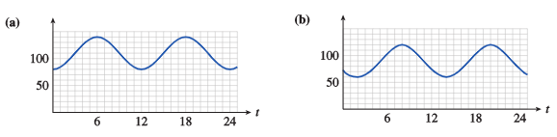

OR

OR

MFG 2.3 HW#76:  The graph of f(x) is a dose-response curve. It shows the intensity of the response to a drug as a function of the dosage x milligrams administered. The intensity is given as a percentage of the maximum response. Write a formula for each transformation of f and explain what it tells you about the response to that drug

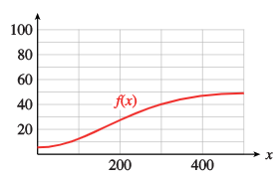

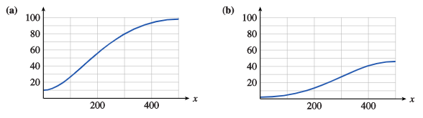

9. APC 1.8 p. 97 HW #6:  Let .

a. Let g(x) = f (x) + 5. Determine AV[−3,−1] and AV[2,5] for both f and g. What do you observe? Why does this phenomenon occur?

b. Let h(x) = f (x − 2). For f , recall that you determined AV[−3,−1] and AV[2,5] in (a). In addition, determine AV[−1,−1] and AV[4,7] for h. What do you observe? Why does this phenomenon occur?

c. Let k(x) = 3 f (x). Determine AV[−3,−1] and AV[2,5] for k, and compare the results to your earlier computations of AV[−3,−1] and AV[2,5] for f . What do you observe? Why does this phenomenon occur?

d. Finally, let m(x) = 3 f (x − 2) + 5. Without doing any computations, what do you think will be true about the relationship between AV[−3,−1] for f and AV[−1,1] for m? Why? After making your conjecture, execute appropriate computations to see if your intuition is correct.